Table of Contents

Object Detection Introduction 1

Downloading Images with Fatkun 1

Annotating Images 2

Training an Object Detection Model 3

Detecto and Faster R-CNN 3

Setup 4

Enabling Custom Image Augmentation 4

Model Training 5

Model Saving, Loading, and Predicting 5

This lab and lesson are combined this week. It is an easy tutorial but it will likely take more than an hour to complete.

# Object Detection Introduction

Object detection is a computer vision task which identifies the existence and location of specific object classes in images and video.

## Downloading Images with Fatkun

To train many images to help your object detection model, I find the Fatkun chrome-plugin to be effective. To obtain many images install the following plug-in:

<https://chrome.google.com/webstore/detail/fatkun-batch-download-ima/nnjjahlikiabnchcpehcpkdeckfgnohf?hl=en>

Example 1: Downloading Images

I have had issues when searching for images when using Google with this plugin. So instead I go to Bing and search on the images of my preference. Then I click on the Images tab.



For the example ahead, I downloaded 50 images. Then I added 15 images to the **Test** folder and 35 images to the **Train** folder.

## Annotating Images

In order to train models for object detection, it is necessary to manually identify objects of interest in train and test images. There really is not any standard image annotator. In the past two years, I have tried about 10 image annotation programs.

The article at <https://www.analyticsvidhya.com/blog/2021/06/simplest-way-to-do-object-detection-on-custom-datasets/> recommends the use of [https://wwwmakesense.ai/](https://www.makesense.ai/) I found it to be easy to use. The ability to expand the library of annotated images for a specific domain is also simple and intuitive.

Example 2: Annotating Images with Makesense.AI

In this example, the Test and Train images that were downloaded will be annotated. XML that contains information about the annotations be exported and placed in the same folders as the images. Here is the Test folder after the annotations have been added (refer to Figure 1).

Figure 1: Images and Corresponding Annotation Information in XML format

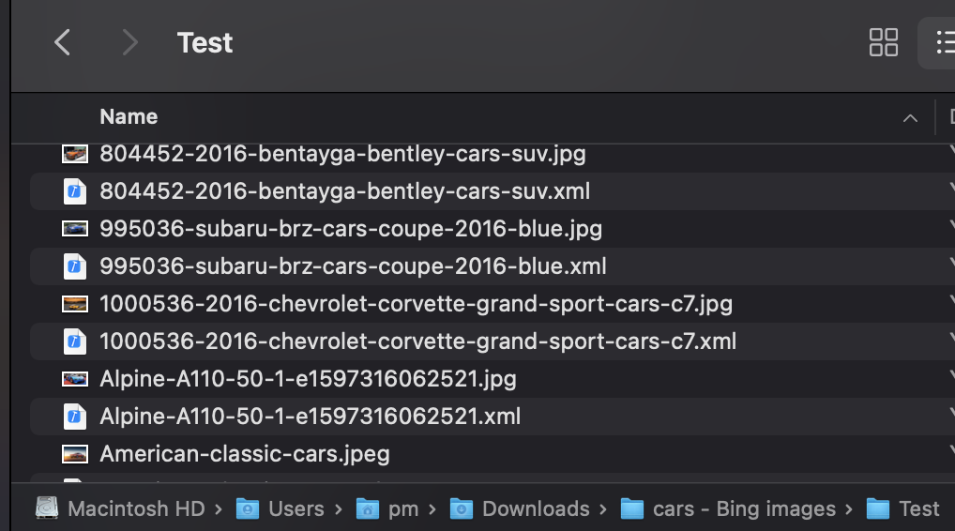

To begin navigate to <https://www.makesense.ai/> and click Get Started. Then select all images from one of your folders only. I recommend annotating the images for the Test and Train folders in separate sessions. Once the images are selected choose **Object Detection**.

 

Then choose **Start Project**. In the steps that follow wheels and lights will be annotated so add labels for *wheels* and *lights* (see Figure 2).

Figure 2: Adding Annotations for Wheels and Lights

|  |  |
| --- | --- |
|  |  |

Then using the Rect tool, surround the objects and label them as needed.



When finished with the current image, navigate to the next image and annotate it and so on.

Once all images are annotated, choose Actions | Export Annotations. When prompted choose the XML format. After, place the XML in the same folder as the images (see Figure 1).



# Training an Object Detection Model

This section is based heavily on the article at <https://chrome.google.com/webstore/detail/fatkun-batch-download-ima/nnjjahlikiabnchcpehcpkdeckfgnohf?hl=en>

## Detecto and Faster R-CNN

This object detection tutorial is based on the article at:

<https://www.analyticsvidhya.com/blog/2021/06/simplest-way-to-do-object-detection-on-custom-datasets/>

One of the reasons that I chose Detecto is that it is a wrapper which creates a simple interface for using Faster R-CNN. Faster R-CNN is a deep convolutional network that is used for object detection. The configuration of object detection models is difficult and is subject to many issues due to version differences. However, Detecto is relatively problem free during setup. Based on my own experience in working with other object detection libraries, Detecto also appears to be one of the easiest to train and evaluate.

Popular competing libraries include YOLO v3, v4 and v5. Using these libraries to implement object-detection requires similar steps as those required by Detecto.

Example 3: Performing Object-Detection with Detecto and R-CNN ResNet-50 FPN

### Setup

‘Detecto’ is built on top of the PyTorch so we need to first install PyTorch.

I have used Google Colab for this project.

Then we need to check whether we have the support of GPU or not using the following code:

|  |
| --- |
| import torch  print(torch.cuda.is_available()) |

If the print is ‘True’, it means you can use GPU. If it is ‘False’, please change the ‘Hardware Accelerator’ of the Notebook Setting to ‘GPU’. Now, your system is ready with the requisition to install ‘[Detecto](https://pypi.org/project/detecto/)’. Use the following code to install it.

|  |
| --- |
| !pip install detecto |

Once the GPU is set upload create **Test** and **Train** folders in the same directory as the **sample_directory** folder. If you do this in opposite order you will have to re-upload your images.

Figure 3: Showing Test and Train Folders which Reside in the content folder  
 

If you ever need to get back to the Test and Train folders you can by navigating to the content folder which is where they reside.  
  
Once the last step is done, import the libraries using the following code:

|  |
| --- |
| from detecto import core, utils, visualize  from detecto.visualize import show_labeled_image, plot_prediction_grid  from torchvision import transforms  import matplotlib.pyplot as plt  import numpy as np |

### Enabling Custom Image Augmentation

Image augmentation is the process of artificially expanding data by creating a modified version of images. Detecto has an inbuilt function to do custom transform by applying to resize, flip, and saturation augmentation. Please, use the following code for augmenting the image dataset.

|  |
| --- |
| custom_transforms = transforms.Compose([  transforms.ToPILImage(),  transforms.Resize(900),  transforms.RandomHorizontalFlip(0.5),  transforms.ColorJitter(saturation=0.2),  transforms.ToTensor(),  utils.normalize_transform(),  ]) |

### Model Training

Now, the model can be trained with five lines of code. The default model is [**Faster R-CNN ResNet-50 FPN**](https://pytorch.org/docs/stable/torchvision/models.html#object-detection-instance-segmentation-and-person-keypoint-detection). We have fine-tuned this model for our custom dataset.

You will also notice that the number of epochs, step size and learning rate can be adjusted.

|  |
| --- |
| Train_dataset = core.Dataset('Train/',transform=custom_transforms) #L1  Test_dataset = core.Dataset('Test/')#L2  loader = core.DataLoader(Train_dataset, batch_size=2, shuffle=True)  # These labels correspond to the labels assigned in makesense.ai  model = core.Model(['wheel', 'headlight'])  # Fit the model.  losses = model.fit(loader, Test_dataset, epochs=25,  lr_step_size=5, learning_rate=0.001, verbose=True) |

Now, we can look at the loss function using the following code:

|  |
| --- |
| plt.plot(losses)  plt.show() |

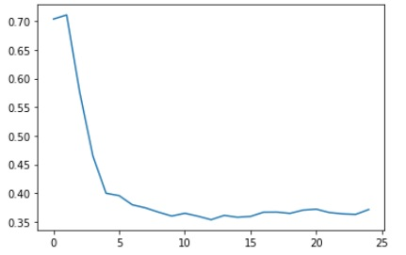

### Model Saving, Loading, and Predicting

Once we are satisfied with a model loss, we need to save the model for future reference. So that we can load it to make predictions when required. Use the following code for saving and loading.

|  |
| --- |
| model.save('model_weights.pth')  model = core.Model.load('model_weights.pth', ['wheel', 'headlight']) |

After loading the model, we want to use it for prediction. Let’s use it for one observation from the Test folder and plot the image with a bounding box. Here, the prediction format is labels, boxes, and scores.

|  |
| --- |
| image = utils.read_image('Test/Maruti car_27.jpeg')  predictions = model.predict(image)  labels, boxes, scores = predictions  show_labeled_image(image, boxes, labels) |

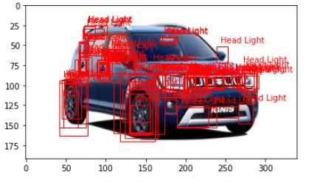

There are too many unwanted bounding boxes in the above picture. The simplest way to remove them is by providing a threshold on the score. For this project, I have put the threshold as 0.6 for both classes. I came to this point through different trials and errors. Use the following code to set up the threshold for bounding boxes and plotting them.

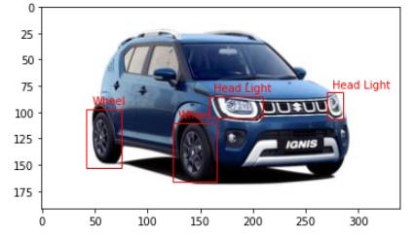

|  |
| --- |
| thresh=0.6  filtered_indices=np.where(scores>thresh)  filtered_scores = scores[filtered_indices]  filtered_boxes = boxes[filtered_indices]  num_list = filtered_indices[0].tolist()  filtered_labels = [labels[i] for i in num_list]  show_labeled_image(image, filtered_boxes, filtered_labels) |

Exercise 1 (10 marks)

Annotate images of an animal that’s first letter is the first letter of your first name. For example if your name is Michael G or Michael L you could choose a monkey or a mouse. The objects to be detected include eyes and mouth so make labels for *eye* and *mouth*. As a minimum, build a test set of 15 and a training set of 35 images. This actually is not many images for object detection so the model will not be very good – annotate more training images for a better model. Perform object-detection on a test image. Increase the threshold to remove any unwanted bounding boxes. Show a screenshot of a test image with the bounding box over an eye or mouth.

|  |
| --- |
| Hedgehog has a very small mouth so I changed the mouth to nose :D  Graphical user interface, application  Description automatically generated  But hedge hog’s eye and nose look so same.. it cannot tell differences ☹ |

## Live Video

Example 4: Performing Object Detection in Live Video

This code can detect objects in live video. It needs to run locally. First, download the model that was saved as a binary file named model_weights.pth and reference the proper path to it.

|  |
| --- |
| from detecto.core import Model  from detecto.visualize import detect_live  model = Model.load('model_weights.pth', ['wheel', 'headlight'])  detect_live(model, score_filter=0.7) |